Crystal Ball Exercise
Crystal Ball® is an add on for Microsoft Excel that easily allows you to:
- Perform Monte Carlo simulation on a spreadsheet that you have constructed
- Identify the probability distribution of a series of data
- Identify a forecast based on a time-series data set
- Calculate the optimal solution of a linear programming system (an advanced Solver)
Crystal Ball is available as a trial version download from Oracle Corporation at: www.oracle.com

Introduction
The owner of Herr Cutter (computer simulation example from the book) has decided to refine his analysis using Crystal Ball. It turns out that the initial estimate of the customer arrival times being exponentially distributed with a mean of 30 was based on a guess. In order to refine the simulation they have measured the inter arrival times for 100 customers.
To refine the simulation we have the following objectives:
- Finding the proper probability distribution for customer arrivals, based on actual data
- Estimate the time that a customer spends waiting for a haircut
- Estimate the total time that a customer spends from arrival to departure
- Estimate the total profit made on each customer
- Identify the percentage of time that profit falls between $17.75 and $19.25 per customer
- Identify the items and the % of the impact that they have on total customer time in the store

Make sure to install Crystal Ball before proceeding with this step by step exercise. You should not, but may have to activate the Crystal Ball add-on in Excel before proceeding.
Customer Inter-Arrival Time  We want to use actual customer inter-arrival times to identify the probability distribution that is best representative of customer inter-arrival times.  Herr Cutter used a stopwatch to measure the time between 100 customer arrivals and this data is stored in the Customer Times sheet. | 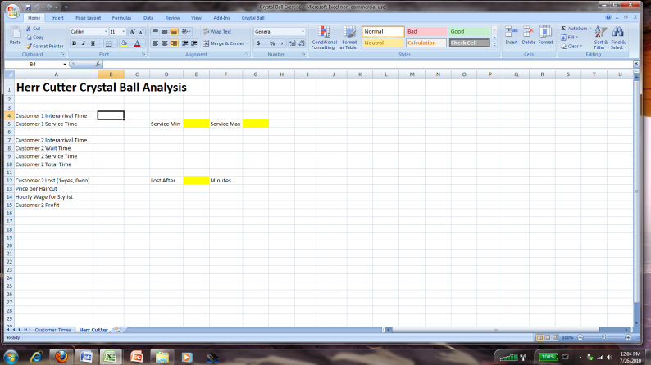
Defining Assumptions  The assumption cells contain the cells that are randomly generated based on a certain probability distribution.  - Click on the Customer 1 Interarrival Time cell (B4).  - Click on the Define Assumption button in the Crystal Ball menu  - Click the Fit button | 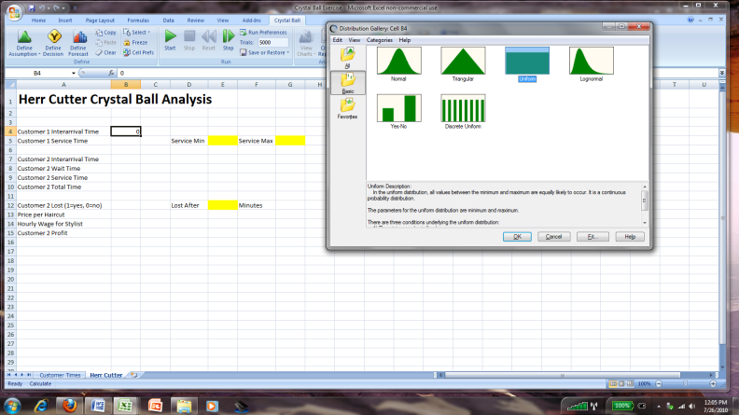
Fitting a Probability Distribution  You do not need to limit the probability distribution or goodness of fit methods used, so do not change the AutoSelect choices from the dialog box.  Press the cell selector from the Range area of the dialog box. | 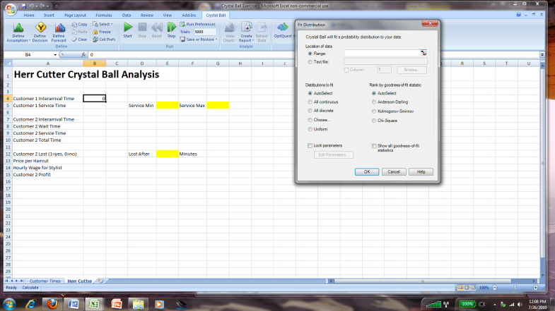
The Cell Reference dialog box will open. Click on the Customer Times sheet. | 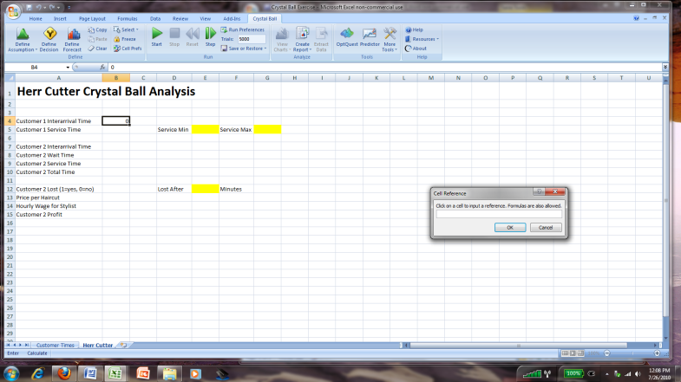
Highlight the Actual Data  The Customer Times sheet contains 100 measurements taken by the Herr Cutter staff on time between customer arrivals.  Highlight the entire range of the actual data (cells B2:B101) and press OK. | 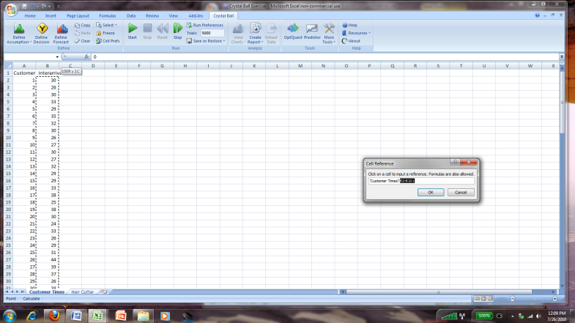
Start the Distribution Fitting Process  Press the OK button in the Fit Distribution dialog box to start the fitting process. | 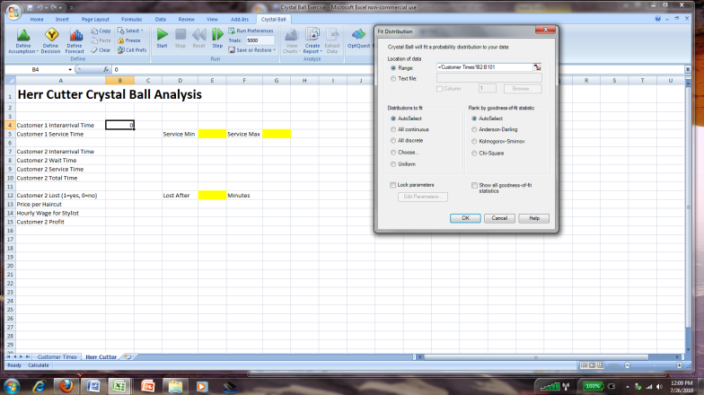
Distribution Fit Comparison Chart  Based on the data selected, the probability distributions that best fit the data are listed in rank order from best fit to worst.  Press the ACCEPT button to accept the best fitting distribution. | 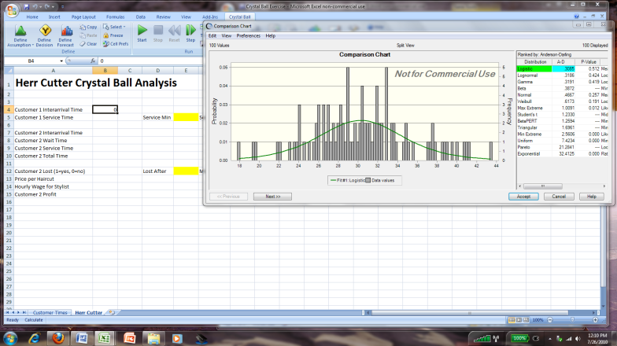
Display of the Best Fit Distribution  The distribution that best fits the data is shown in the Define Assumption dialog box, with the distribution parameters already entered.  Press the OK button to accept this distribution and its parameters. | 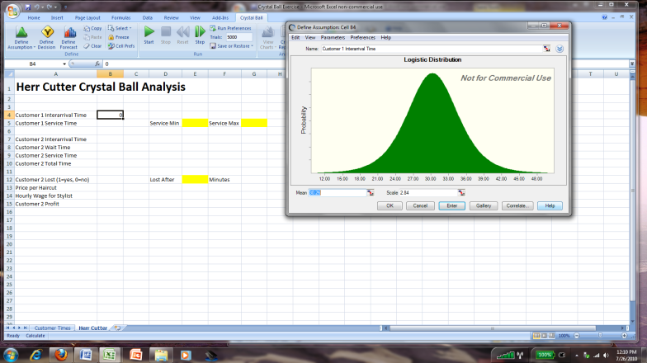
Customer 1 Interarrival Time  Assumptions defined in the Crystal Ball model are highlighted in green. | 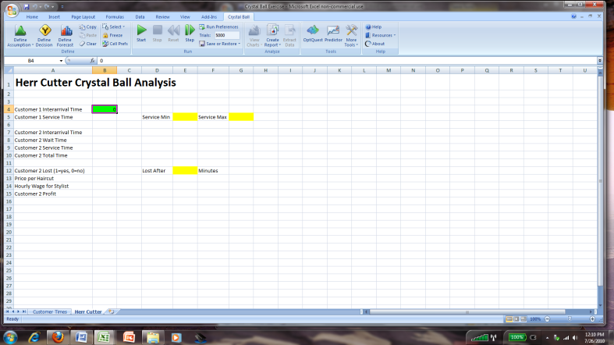
Customer 2 Interarrival Time  The 2nd customer is modeled to predict the chance of waiting due to the 1st customer’s haircut running long. The statistics of note are all based on the 2nd customer’s average experience at Herr Cutter.  Repeat the process to Define an Assumption for the Customer 2 Interarrival Time (cell B7). | 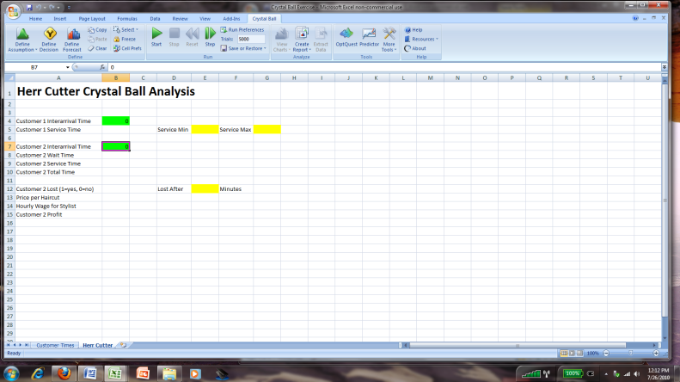
Haircut Service Times  Herr Cutter has refined their estimates on the time that it takes to perform a hair cut. They have moved up market into more fancy styles.  Hair cuts take a minimum of 25 and maximum of 40 minutes, and any value between this min and max are equally likely. Enter these values in cells E5 and G5 | 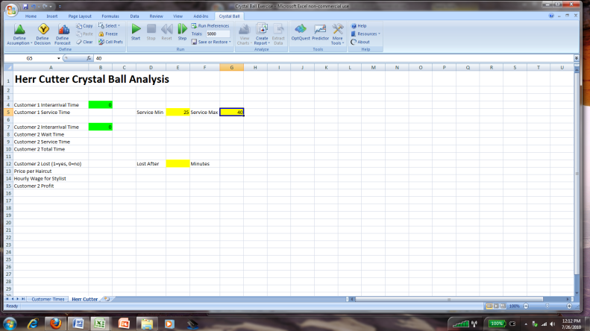
Define Customer 1 Service Time  We will again Define an Assumption for service times, but instead of using the distribution fit function, we know the distribution and its parameters.  Highlight cell B5 and then click the Define Assumption button in the Crystal Ball menu.  Select the uniform distribution and press the OK button. | 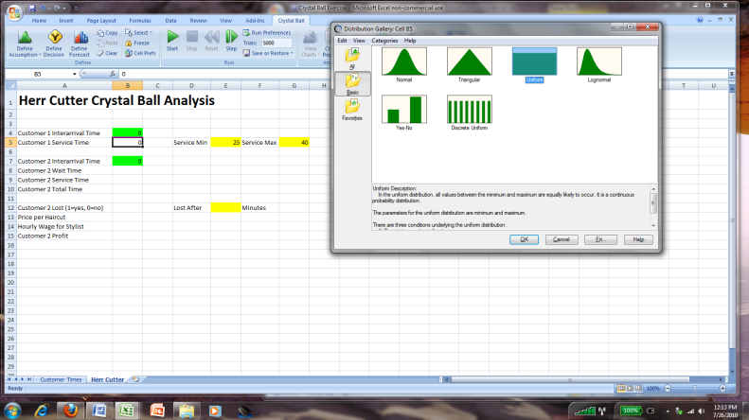
Enter Parameters of the Distribution  The Uniform Distribution is described by a minimum and maximum value. These values are in cells E5 and G5.  Reference these cells in the minimum and maximum values in the Define Assumption dialog box and press the OK button. | 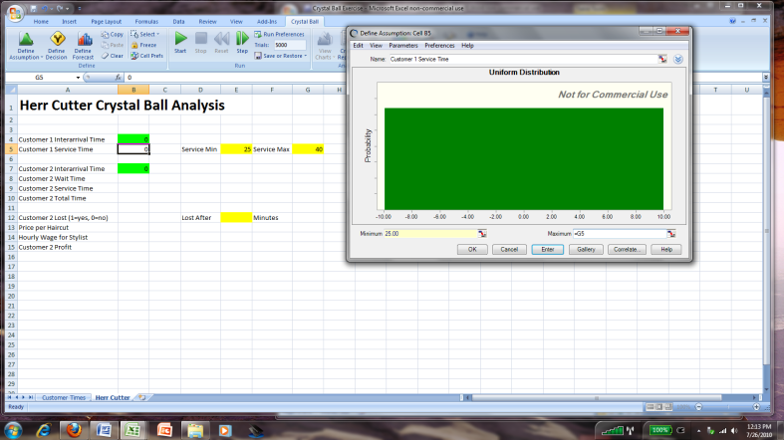
Repeat for Customer 2 Service Time  Repeat the same process to define the service time Assumption for customer 2 (in cell B9). | 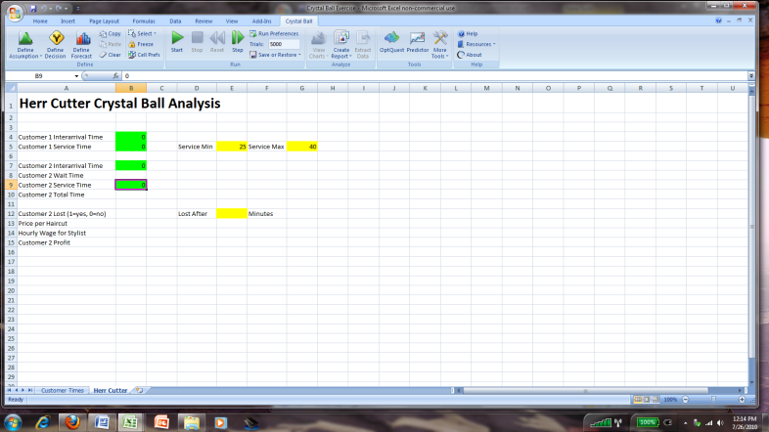
Customer 2 Wait Time  The 2nd customer to arrive will have to wait only if they arrive before the 1st customer to arrive’s haircut takes longer than their arrival time. If the 1st customer’s haircut is faster than the arrival time of customer 2, their wait is 0.  Enter formula =IF(B7<B5,B5-B7,0) in cell B8 to represent the calculation of customer 2’s wait time. | 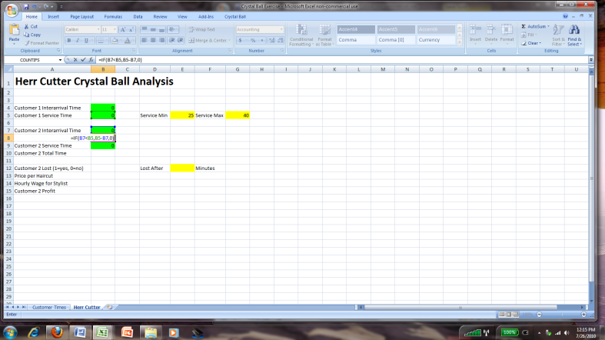
Customer 2 Total Time  The total time that customer 2 spends in the shop is the total of their wait time + their service time.  Enter formula =B8+B9 into cell B10 to represent this calculation of total time for customer 2. | 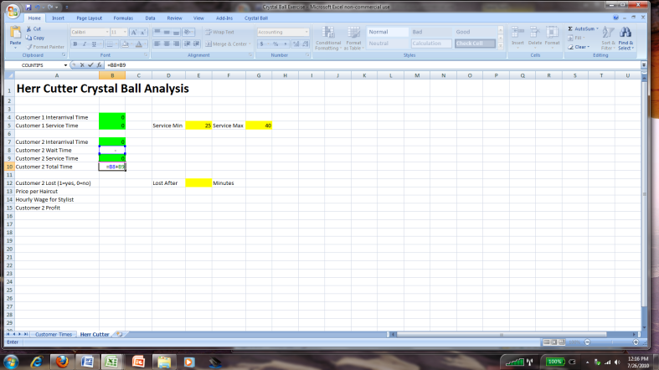
Customers Lost  Customers will not wait forever for a haircut. Herr Cutter has found that customers will only wait about 6 minutes before they leave the shop.  Enter 6 into cell E12 to represent this time.  Enter formula =IF(B8>E12,0,1) in cell B12 to show a 0 if the customer is lost and 1 if not. | 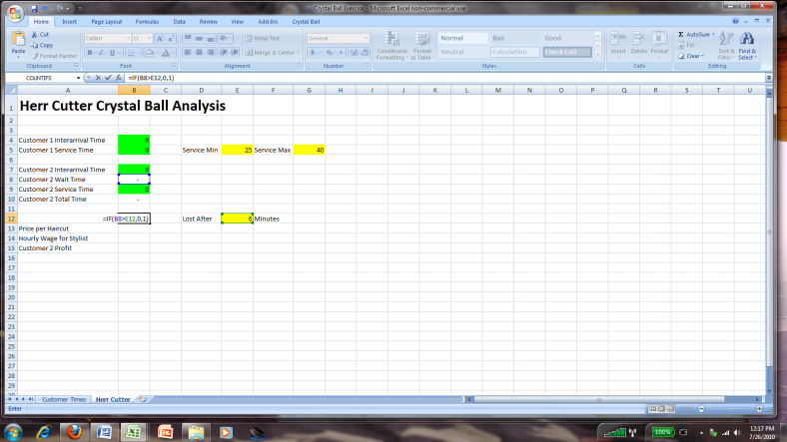
Prices, Wages and Profit  Herr Cutter charges $25 per haircut and pays their staff $12 per hour. Enter these two values in cells B13 and B14.  The profit for a haircut is the price – (mins of service * hourly rate / 60). The profit is only gained if the customer is not lost.  Enter formula =(B13-((B14/60)*B9))*B12 into cell B15 to calculate the profit. | 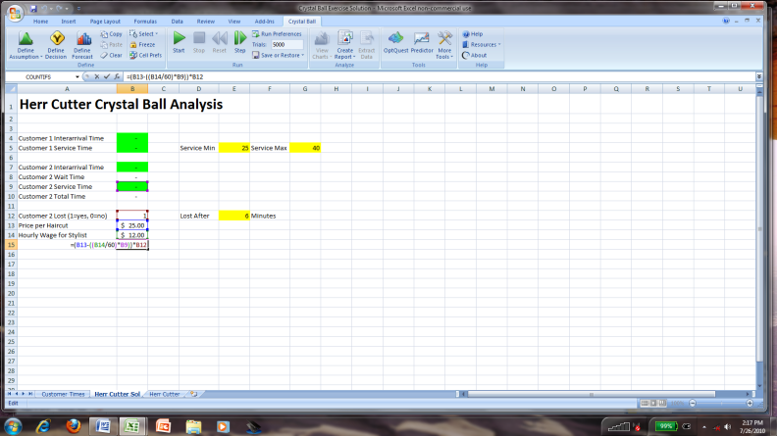
Define Forecast for Wait Time  You Define Forecast cells for all values you wish to analyze after the simulation is run. Highlight cell B8 and press the Define Forecast button in the Crystal Ball menu. | 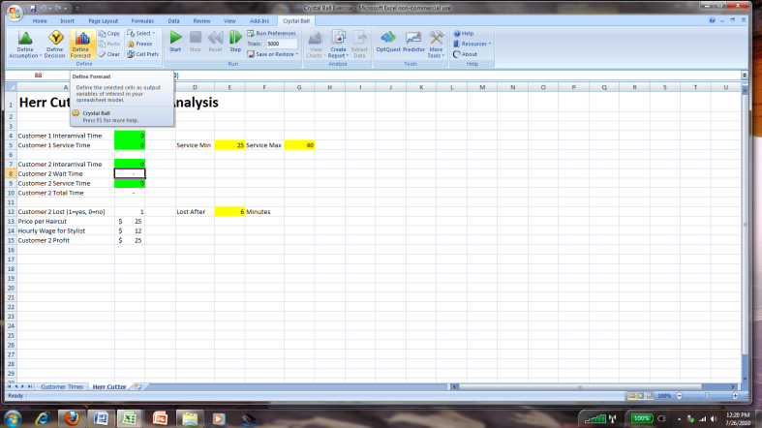
Define Forecast  Press the OK button to accept the defaults for the Define Forecast dialog box. | 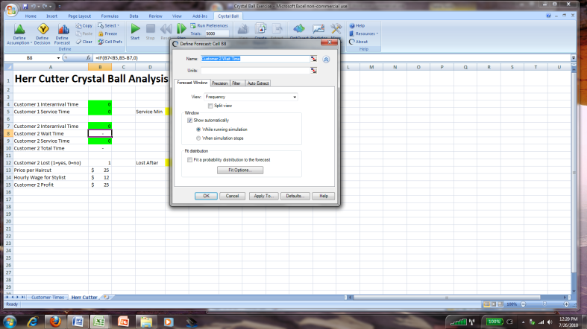
Define Forecast Completed  Crystal Ball highlights Forecast cells in light blue. | 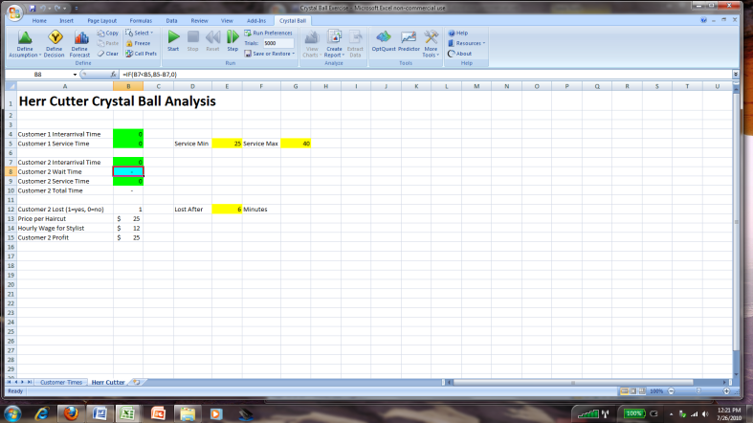
Repeat for Total Time, Lost & Profit  We are also interested in statistics for the total time spent, customers lost and profit per customer cells.  Repeat the Define Forecast process for cells B10, B12 and B15. | 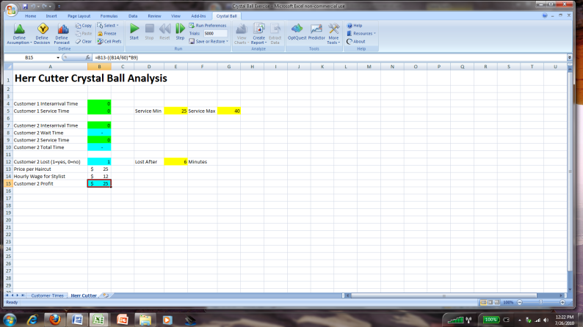
Start Simulation  When you start the simulation Crystal Ball will randomly generate values for each of the Assumption cells based on the probability distributions that you defined for those cells. It will then gather statistics on each of the forecast cells as it repeats this process for a few thousand times.  Press the START button for Crystal Ball. | 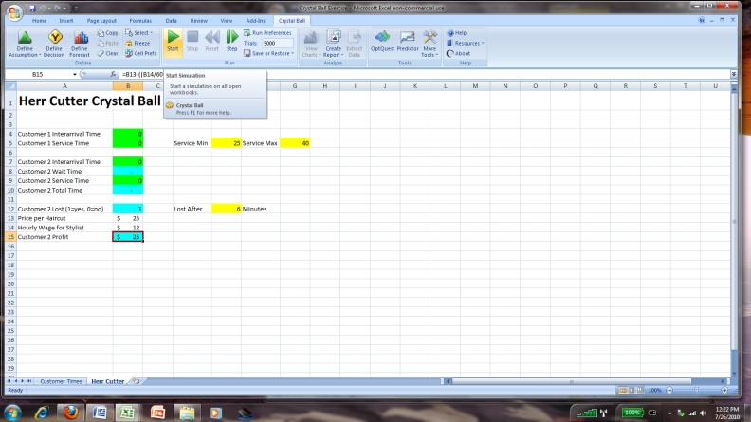
Crystal Ball Results Display  The results of the Monte Carlo simulation are shown once the simulation has run 5,000 times (the default # of repetitions).  Notice that the profit is either 0 (if the customer had to wait longer than 6 mins and was lost) or in a range around $19 if they were not. | 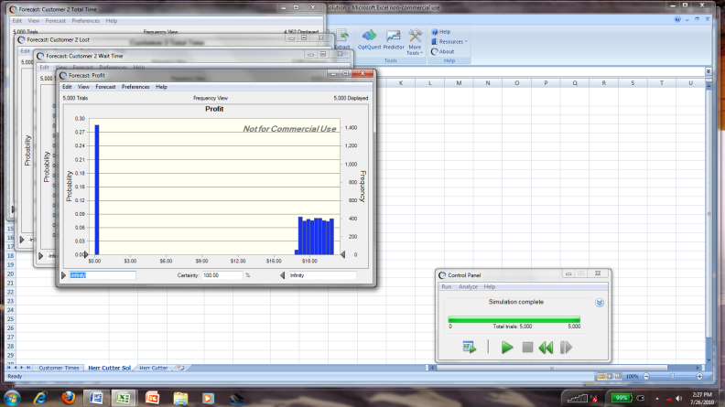
Split View for Statistics  Click on the View menu on the Forecast:Profit box. Then click the Split View choice to show a split view with both the frequency distribution graph and statistics relating to the profits generated over the 5,000 trials run.  Statistics on profit include minimum, mean, maximum and standard deviation. | 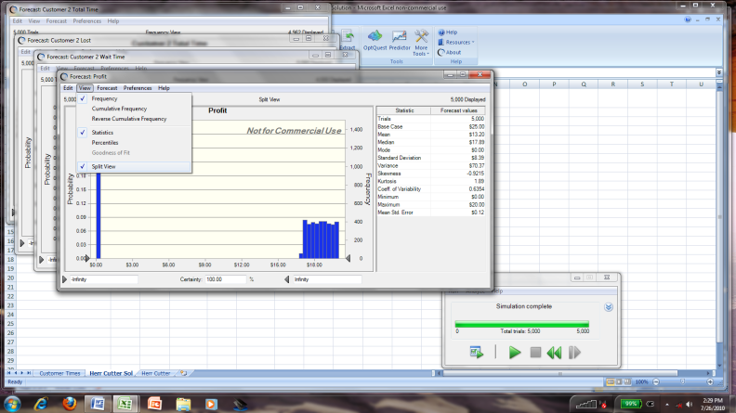
Range Analysis  Crystal Ball makes it easy to find the probability that the result will fall between a given range.  Drag the arrow at the bottom of the x-axis to the right until it shows about $16.50.  Notice at the bottom it shows that it is 71.38% likely that profit will be >$16.50 per customer. | 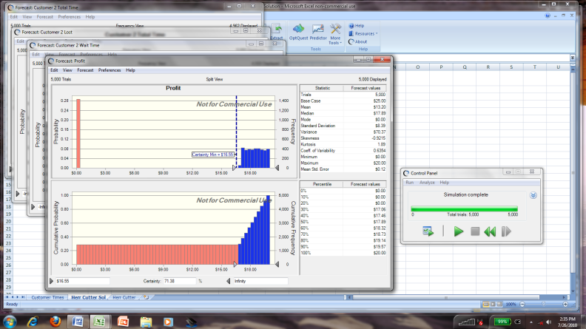
Upper Range  This works the same way for the upper bound of a range. Drag the arrow on the right side of the x-axis to the left until it shows about $19.51.  The certainty number now shows that profit will be between $16.55 and $19.51 about 59.91% of the time.  (results on your sheet will slightly vary). | 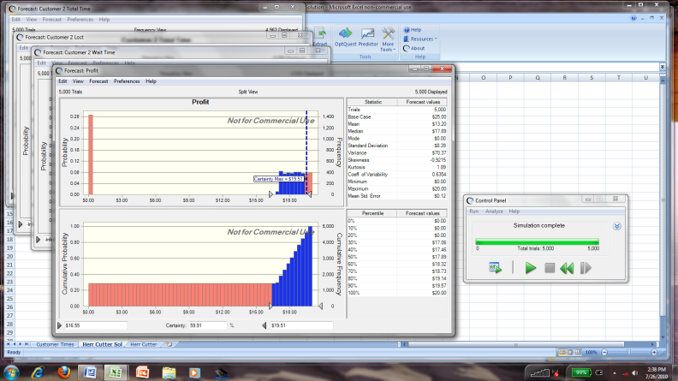
Sensitivity Chart  To view the items that contribute to or detract from profit, click on Forecast and then Open Sensitivity Chart in the Forecast:Profit dialog box.  This shows the level of contribution to the changes in profit of each item. | 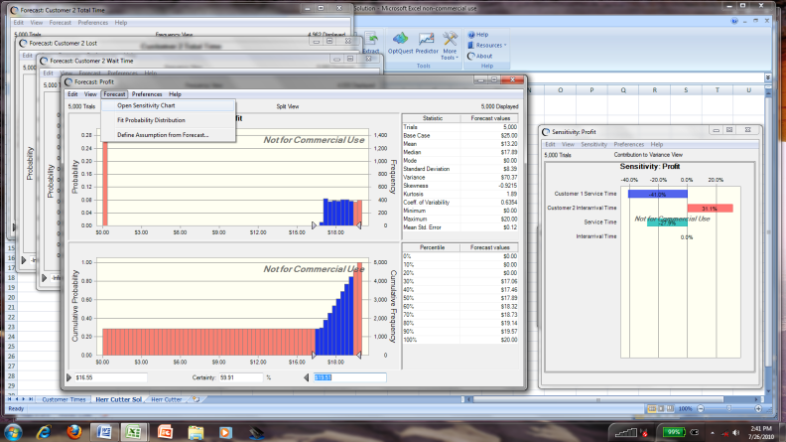
Extra Credit  To qualify for the 10 pointsof extra credit, answer the following questions and send your answers via email to knappk@uindy.edu. | Using the reports on the forecast values:  - About what % of customers are lost?  - What is the % of customers who wait >5mins?  - What is the average total time spent by a customer from start to finish?

